2016年3月27日星期日

季度阶段总结

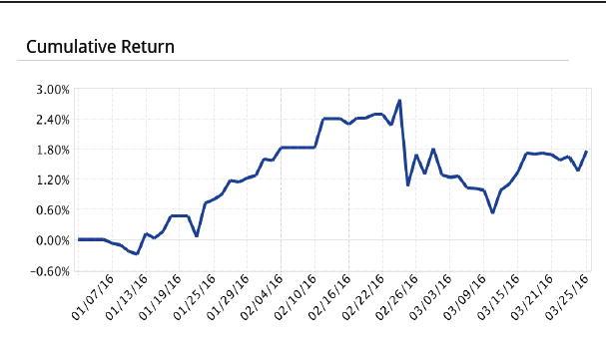

This quarter was the first quarter of positive return. There is a big profit gap between potentially what could be achieved versus the results. The major setback occurred on Feb 25, a Thursday which was catastrophic (sep 1- percentileY @ 100% missed). The day was a combination of Thursday, low open and AM High in early morning, all signs pointing to an extreme weakly session. March has been relatively flat because of position sizing issues. Sometimes heavy position was held overnight which crippled trading the next day; sometimes too much had been bought intraday already too early such that one is afraid to buy at the most panicky times. This is where the profit gap comes from. Also, long position was not held during a bullish period (week of Mar 14) and held during the bearish period (week of Mar 21).

Key lessons going forward:

1. During bull market, opening high on Mon, Wed, Fri make sure you have some position, especially if the level is low compared with recent levels.
2. Do not carry heavy position overnight
3. Do not buy consecutively too early. Wait for the index to further go down to make the entrance point attractive. (sep1 – add after 11am fine)
4. Up until now the positions have been purely long. Shorts on Thursday at the highs are permitted to a certain extent. But no short position on other days since these are hard to manage and beyond your current capability.
5. Be mindful of strength of rebound on Tuesday and Wednesday because these are important indicators of market strength, see if they are at least on par or greater than the average retCL for the specific weekdays.